Click “Stat” and mouse over “Summary Stats” to reveal the option to click “Columns”

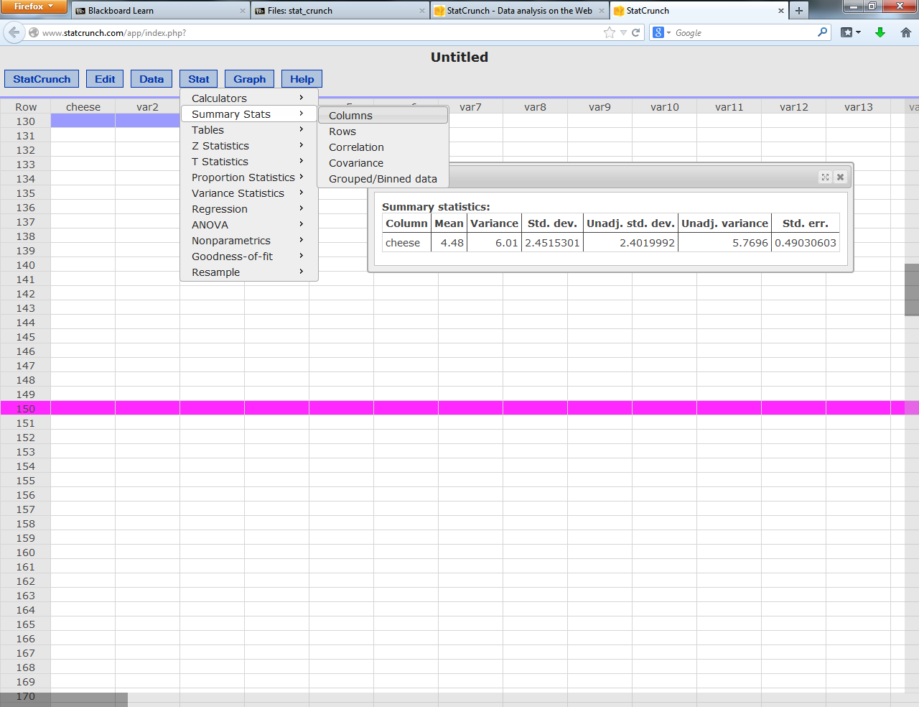

In the second window select the following:

Mean = average

N = number of scores

Unadj variance = variance of the scores with N on the bottom (chapter 2), we will use real variance later, be sure to use unadj for chapter 2.

Unadj std dev = standard deviation with N on the bottom (chapter 2). See note above.

